Omninet:
The Internet Everywhere
System Requirements Document

Ver. | Date | Author | Description | Approved By | Date
0.1 | June 14, 2003 | Rex Black | First Draft
0.2 | July 1, 2003 | Rex Black | Second Draft

This document contains proprietary and confidential material of RBCS, Inc. Any unauthorized reproduction, use, or disclosure of this material, or any part thereof, is strictly prohibited. This document is solely for the use of RBCS employees and authorized RBCS course attendees.

Functionality System Requirements
The capability of the system to provide functions which meet stated and implied needs when the software is used under specified conditions.
ID. | Ver | MRD | Description | Priority∗
010-010 |  |  | Suitability
010-010-010 | 1.0 | 3.1 | Kiosk design shall be suitable for installation in public places. | 1
010-010-020 | 1.0 | 3.1 | Kiosks shall allow access to Internet sites through all supported URLs. | 1
010-010-030 | 1.0 | 3.1 | Kiosks shall provide a standard keyboard-video-mouse graphic user interface. | 1
010-010-040 | 1.0 | 3.1 | Call center desktops shall provide agents with a standard keyboard-video-mouse graphic user interface. | 2
010-010-110 | 1.0 | 3.1.6 | Kiosks shall accept payment in local currencies. | 2
010-010-210 | 1.0 | 3.1.5 | Kiosks shall be configured to interact with customers entirely in the primary local language from the Welcome screen until session termination. | 1
010-010-220 | 1.0 | 3.15 | At the Welcome screen, kiosks shall allow users to select a secondary local language where appropriate. Once this language is selected, the kiosk shall interact with customers entirely in this language until session termination. | 2
010-010-230 | 1.0 | 3.15 | All kiosk Web browsers shall be able to display Web pages in (US) English, (Mexican) Spanish, and (Canadian) French in addition to all primary and secondary local languages for which the kiosk is configured. | 2
010-010-240 | 1.0 | 3.15 | All kiosk Web browsers shall be able to display Web pages in Hebrew, Arabic, German, (Mandarin) Chinese, (Hong Kong) Chinese, Japanese, and Russian. | 3
010-010-250 | 1.0 | 3.15 | All kiosk Web browsers shall be able to display Web pages in languages other than those specified in 010-010-230 and 010-010-240. | 4
010-010-910 | 1.0 | 3.1.7 | Kiosks shall allow users to terminate sessions at any time by clicking the “Log Out” icon on the taskbar. | 1
010-010-920 | 1.0 | 3.1.2 | At any time while the user is browsing the Web, kiosks shall allow users to purchase more time by clicking on the “Buy Time” icon on the taskbar. | 3
010-010-930 | 1.0 | 3.1.2 | Exactly 60 seconds before a session expires, kiosks shall present users with a message that gives them the option to return to the payment screen and purchase additional time. The user may accept the option or decline. | 1
010-010-940 | 1.0 | 3.1.7 | Kiosks shall automatically terminate a user’s sessions within 1 second of the expiration of the user’s currently purchased blow of time. | 1
 |  |  | [More TBD]
010-020 |  |  | Accuracy
010-020-010 |  | 3.1.3 | All supported e-mail attachments and Web pages (see section 010-030) shall be visible on kiosks without any noticeable distortion from their sources on their originating systems. Scrolling shall not be considered distortion. | 2
 |  |  | [More TBD]
010-030 |  |  | Interoperability
010-030-010 |  | 3.1.3 | The kiosks shall allow users to send and receive e-mail to and from other Omninet kiosks. | 1
010-030-020 |  | 3.1.3 | The kiosks shall allow users to send and receive e-mail to and from other Windows and Linux PCs running e-mail and operating system software not more than two years old. | 2
010-030-030 |  | 3.1.3 | The kiosks shall allow users to send and receive e-mail to and from Macintosh PCs. | 3
010-030-040 |  | 3.1.3 | The kiosks shall allow users to send and receive e-mail to and from other systems such as mainframes, Unix servers, VMS servers, PCs (those running e-mail or operating system software more than two years olds older or those not running Windows, Linux, or Mac) and other systems. | 5
 |  |  | [More TBD]
010-040 |  |  | Security
010-040-010 | 1.0 | 3.16 | A firewall running on the kiosk shall protect each kiosk against inbound or outbound virii, worms, other malicious code, and hacking via a firewall. Upon detection of any such item, the firewall shall report such security events to the application server. | 1
010-040-020 | 1.0 | 3.16 | Filtering software running at the server farm shall protect each kiosks against inbound or outbound pornographic, objectionable, lewd, obscene, violent, or other inappropriate material. Upon detection of any such item, the filtering software shall report such security events to the application server. | 1
010-040-030 | 1.0 | 3.16 | Upon report of a security event, the application server shall send a log entry to the database server to place the event in a database table. | 1
010-040-040 | 1.0 | 3.16 | Logged security events in the database table shall be maintained for at least one year. | 3
010-040-040 | 1.0 | 3.16 | Upon report of a security event, the application server shall escalate the event to an active call center agent desktop. (Active is defined as currently logged in and not locked.) The agent so alerted shall take action in accordance with the current security policies for handling security events. | 1
010-040-050 | 1.0 | 3.16  3.2.5 | Subject to the current security policies for handling security events, a call center agent shall be able to terminate the session for a user who sends malicious code or inappropriate material, or who uses the kiosk to hack other systems. The user whose session is so terminated shall receive a message that includes a toll-free number to call to appeal the decision. | 2
010-040-060 | 1.0 | N/A | Subject to the current security policies for handling security events, a call center agent shall be able to log in to their desktop system at the beginning of each shift and log out at the end of each shift. | 1
010-040-070 | 1.0 | N/A | Subject to the current security policies for handling security events, a call center agent shall be able to lock their current login session on their desktop system prior to leaving their desk. | 2
 |  |  | [More TBD]
010-050 |  |  | Compliance (functionality standards/laws/regs)
 |  |  | [TBD]

Reliability System Requirements
The capability of the system to maintain a specified level of performance when used under specified conditions.
ID. | Ver | MRD | Description | Priority
020-010 |  |  | Maturity
020-010-010 | 1.0 | 3.1.3 | Except as noted in 020-010-030, the server farm shall make available to the kiosks the latest drivers, patches, and other updates for Linux or Windows (as appropriate) only after each update has been available for at least 30 days, Technical Support has documented all known issues, and the Change Control Board has approved the update. | 3
020-010-020 | 1.0 | 3.1.3 | Except as noted in 020-010-030, the server farm shall make available to the kiosks the latest drivers, patches, and other updates for Internet Explorer, Netscape, or Opera (as appropriate) only after each update has been available for at least 30 days, Technical Support has documented all known issues, and the Change Control Board has approved the update. | 3
020-010-030 | 1.0 | 3.1.6 | The server farm shall make available to the kiosks the latest virus, worm, malicious code, and blocked Web site definitions. | 1
 |  |  | [More TBD]
020-020 |  |  | Fault-tolerance
020-020-010 | 1.0 | 3.1.2 | Should the network connection fail during payment approval, the kiosk shall complete the transaction if the customer has been charged. The kiosk shall not complete the transaction if the customer has not been charged. | 1
020-020-020 | 1.0 | 3.1.2 | Should the network connection fail during payment approval, the kiosk shall not complete the transaction if the customer has not been charged. | 2
 |  |  | [More TBD]
020-030 |  |  | Recoverability
 |  |  | [TBD]
020-040 |  |  | Compliance (reliability standards/laws/regs)
 |  |  | [TBD]

Usability System Requirements
The capability of the system to be understood learned, used, and attractive to the user and the call center agents when used under specified conditions.
ID. | Ver | MRD | Description | Priority
030-010 |  |  | Understandability
030-010-010 | 1.0 | 3.1 | The kiosk user interface shall preserve the commonly-understood Microsoft Windows look-and-feel. | 2
030-010-010 | 1.0 | 3.1 | Call center agent desktop user interface shall preserve the commonly-understood Microsoft Windows look-and-feel. | 2
 |  |  | [More TBD]
030-020 |  |  | Learnability
 |  |  | [TBD]
030-030 |  |  | Operability
030-030-010 | 1.0 | 3.1 | The kiosk user interface shall not require the user to navigate through more than five unique pages before accessing the Web browser. | 2
030-030-020 | 1.0 | 3.1 | The call center desktop agent user interface shall not require the user to navigate through more than five unique pages before accessing the any of the major call-center functions. | 2
 |  |  | [More TBD]
030-040 |  |  | Attractiveness
 |  |  | [TBD]
030-050 |  |  | Compliance (usability standards)
 | 1.1 |  | System shall comply with local handicap-access laws. | 5

Efficiency System Requirements
The capability of the system to provide appropriate performance, relative to the amount of resources used under stated conditions.
ID. | Ver | MRD | Description | Priority
040-010 |  |  | Time behavior
040-010-010 | 1.0 | 3.1.1 | The kiosk shall present the Welcome screen within 120 seconds of initial kiosk power up 95% of the time. In no case shall the time exceed 240 seconds. | 1
040-010-020 | 1.0 | 3.1.1 | The kiosk shall present the Welcome screen within 15 seconds of completion of the previous session 95% of the time. In no case shall the time exceed 30 seconds. | 1
040-010-030 | 1.0 | 3.1.2 | The kiosk shall present the first payment screen within 0.5 seconds of a potential customer touching the screen, mouse, or keyboard, 95% of the time. In no case shall the time exceed 1.5 seconds. | 2
040-010-040 | 1.0 | 3.1.2 | Excluding any user and credit/debit card approval delays, the kiosk shall complete payment processing no more than 15 after presenting the first payment screen 95% of the time. In no case shall the time exceed 30 seconds. Should any credit/debit card approval delay exceed 30 seconds, the kiosk shall present the user with the option of canceling the transaction. | 2
040-010-050 | 1.0 | 3.1.2 | In the case that any user or credit/debit card approval delay reaches 60 seconds, the kiosk shall cancel (time-out) the transaction. The user may re-attempt the transaction. | 2
 |  |  | [More TBD]
040-020 |  |  | Resource utilization
040-020-010 | 1.0 | 2 | The server farm shall support 1,000 kiosks, all of which may be simultaneously active. | 2
040-020-020 | 1.0 |  | The server farm shall support 25 call center agent desktops, all of which may be simultaneously active. | 2
 |  |  | [More TBD]
040-030 |  |  | Compliance (performance standards)
 |  |  | [TBD]

Maintainability System Requirements
The capability of the system to be modified. Modifications may include corrections, improvement, or adaptations of the software changes in environments, and in requirement s and functional specifications.
ID. | Ver | MRD | Description | Priority
050-010 |  |  | Analyzability
 | 1.0 |  | The development and maintenance organizations shall maintain traceability between marketing requirements, system requirements, quality risks, test suites, and test cases. | 1
 |  |  | [More TBD]
050-020 |  |  | Changeability
050-020-010 | 1.1 |  | The server farm shall support up to 100 call center agents. | 2
050-020-020 | 1.1 |  | The server farm shall support up to 5,000 kiosks. | 2
 |  |  | [TBD]
040-030 |  |  | Compliance (performance standards)
 |  |  | [TBD]

Portability System Requirements
The capability of the system to be transferred from one environment to another.
ID. | Ver | MRD | Description | Priority
060-010 |  |  | Adaptability
060-010-010 | 1.0 |  | The kiosk hardware shall support Linux. | 1
060-010-010 | 1.1 |  | The kiosk hardware shall support Windows XP. | 2
 |  |  | [More TBD]
060-020 |  |  | Installability
060-020-010 | 1.0 |  | The server farm shall push appropriate updates (for OS, browser, and kiosk software) to the kiosks upon identifying a back-level version of software in a kiosk. | 1
 |  |  | [More TBD]
060-030 |  |  | Co-existence
060-030-010 | 1.0 |  | The kiosks shall support viewing Adobe Acrobat documents on Web pages. | 3
 |  |  | [More TBD]
060-040 |  |  | Replaceability
060-040-010 | 1.0 |  | The server software shall be written to be portable across Web server, application server, and database server vendors. | 2
 |  |  | [More TBD]
060-050 |  |  | Compliance
060-050-010 | 1.0 |  | The kiosk software shall be implemented to work on any standards-compliant browser. | 3
060-050-020 | 1.0 |  | The server software shall be written using industry-standard database and programming languages. | 1
 |  |  | [More TBD]

Design Models

Omninet System Architecture

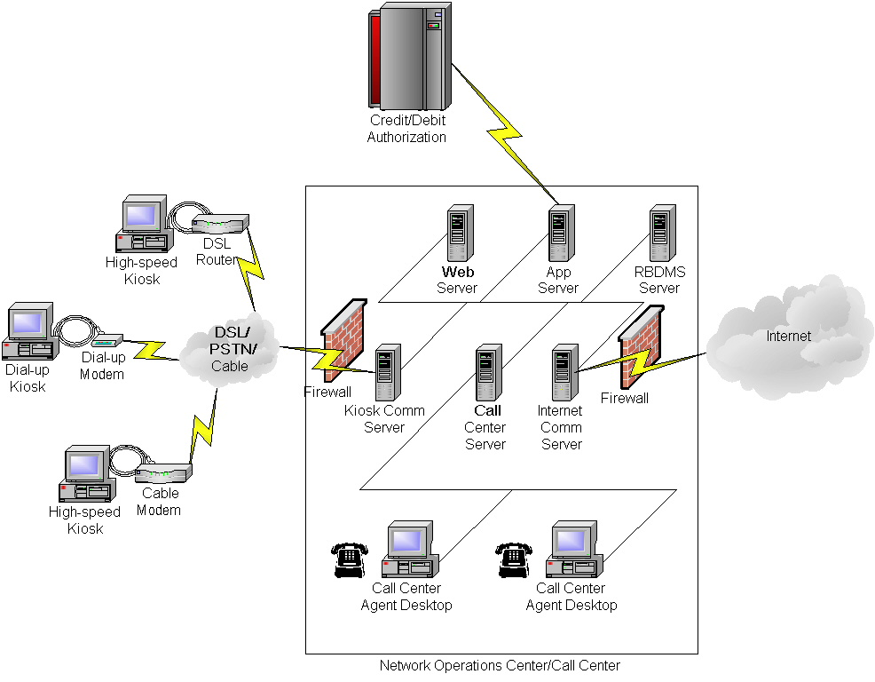

Payment Processing Decision Table

The following decision table shows the business rules that govern processing of payments. The processing of payments logic that authorizes credit and/or debit cards runs on the application server. The processing of payments logic that verifies legitimate currency or correct card runs on the kiosk.

 | Business Rule
Condition | 1 | 2 | 3 | 4 | 5 | 6
Valid money | No | Yes | - | - | - | -
Valid card | - | - | No | Yes | Yes | Yes
Valid PIN (for debit) or no PIN required (for credit) | - | - | - | No | Yes | Yes
Amount approved | - | - | - | - | No | Yes
Action
Reject cash | Yes | No | No | No | No | No
Reject card | No | No | Yes | Yes | No | No
Prompt for lower amount | No | No | No | No | Yes | No
Sell time block | No | Yes | No | No | No | Yes

Kiosk Module Flow

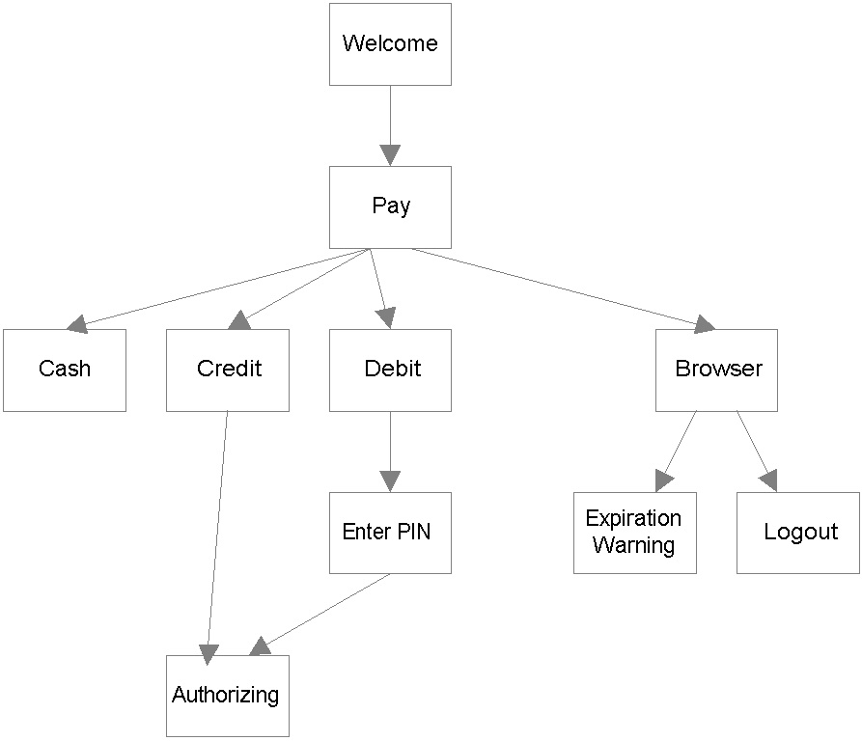

Kiosk State-Transition Diagram

The following diagram shows the states that the kiosk can be in, the transitions that can occur between states, and the events, conditions, and actions associated with those transitions.

TBD

Kiosk State-Transition Table

The following table shows the state transitions that can occur based on the events and conditions that can influence the kiosks behavior.
NB: The following events can occur:
Logout The user terminates the active kiosk session.
Terminate A call center agent terminates the active kiosk session.
URL The user enters a URL (which may be browseable or blocked)
Pay The user submits some form of payment (currency, credit card, or debit card) to the kiosk (which may be valid or invalid) to begin or continue a kiosk session

TBD

Starting State | Event [Condition] | Action | New State

Kiosk OS/Browser/Connection Speed Configuration Orthogonal Array

The following orthogonal array shows the configuration options (singletons and pairs) that will need to be tested.
TBD: One of these arrays will work.
 | Factors
Config | 1 | 2 | 3
1 | 0 | 0 | 0
2 | 0 | 1 | 1
3 | 1 | 0 | 1
4 | 1 | 1 | 0

 | Factors
Config | 1 | 2 | 3 | 4
1 | 0 | 0 | 0 | 0
2 | 0 | 1 | 1 | 2
3 | 0 | 2 | 2 | 1
4 | 1 | 0 | 1 | 1
5 | 1 | 1 | 2 | 0
6 | 1 | 2 | 0 | 2
7 | 2 | 0 | 2 | 2
8 | 2 | 1 | 0 | 1
9 | 2 | 2 | 1 | 0

 | Factors
Config | 1 | 2 | 3 | 4 | 5
1 | 0 | 0 | 0 | 0 | 0
2 | 0 | 1 | 1 | 1 | 1
3 | 0 | 2 | 2 | 2 | 2
4 | 0 | 3 | 3 | 3 | 3
5 | 1 | 0 | 1 | 2 | 3
6 | 1 | 1 | 0 | 3 | 2
7 | 1 | 2 | 3 | 0 | 1
8 | 1 | 3 | 2 | 1 | 0
9 | 2 | 0 | 2 | 3 | 1
10 | 2 | 1 | 3 | 2 | 0
11 | 2 | 2 | 0 | 1 | 3
12 | 2 | 3 | 1 | 0 | 2
13 | 3 | 0 | 3 | 1 | 2
14 | 3 | 1 | 2 | 0 | 3
15 | 3 | 2 | 1 | 3 | 0
16 | 3 | 3 | 0 | 2 | 1

 Priorities are: 1 Very high 2 High 3 Medium 4 Low 5 Very low.

